1. **Alarm should sound in one manner temperature is above60C**

**(circuitdiagram)**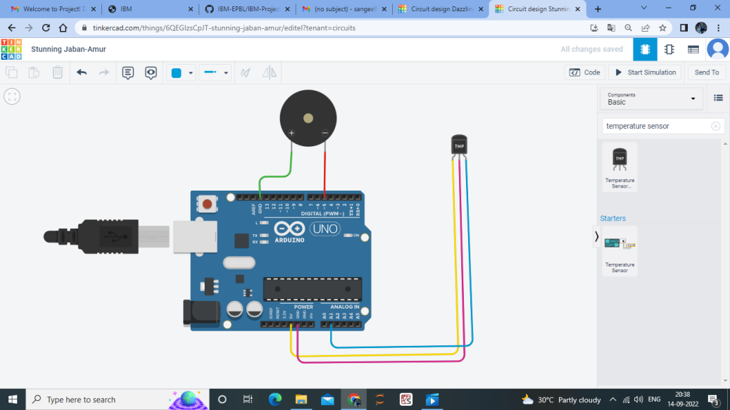

**CODING FOR CIRCUIT**

**void setup()**

**{**

**Serial.begin(9600);**

**pinMode(5,OUTPUT);**

**}**

**void loop()**

**{**

**int data=analogRead(A0);**

**double n=data/1024;**

**double volt=n*6;**

**double off=volt-0.6;**

**double temperature=off*100;s**

**Serial.println(temperature);**

**tone(5,100);**

**delay(1000);**

**tone(5,200);**

**delay(1000);**

**}**

**CODING WITH CIRCUIT**

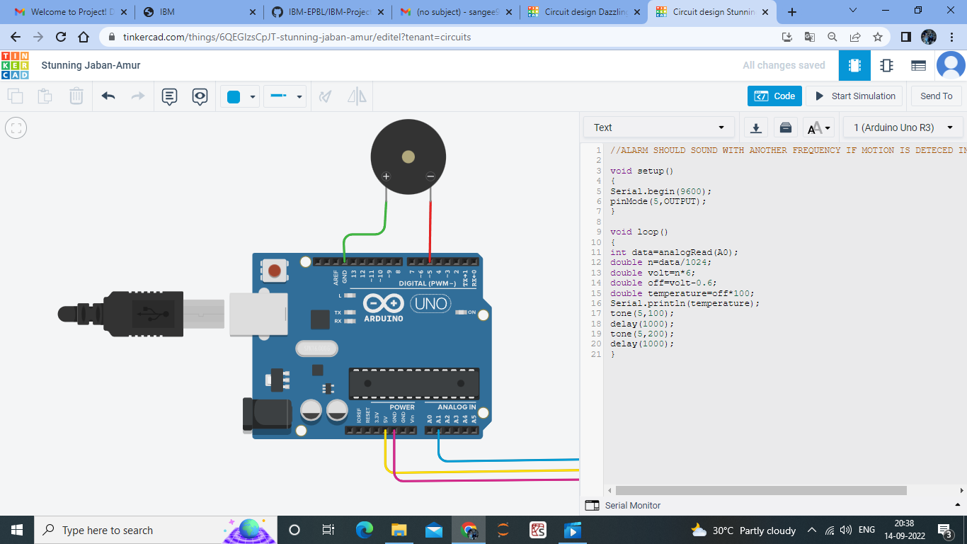

1. **Alarm should sound with another frequency if motion is detected in PIR sensor(circuit diagram)**

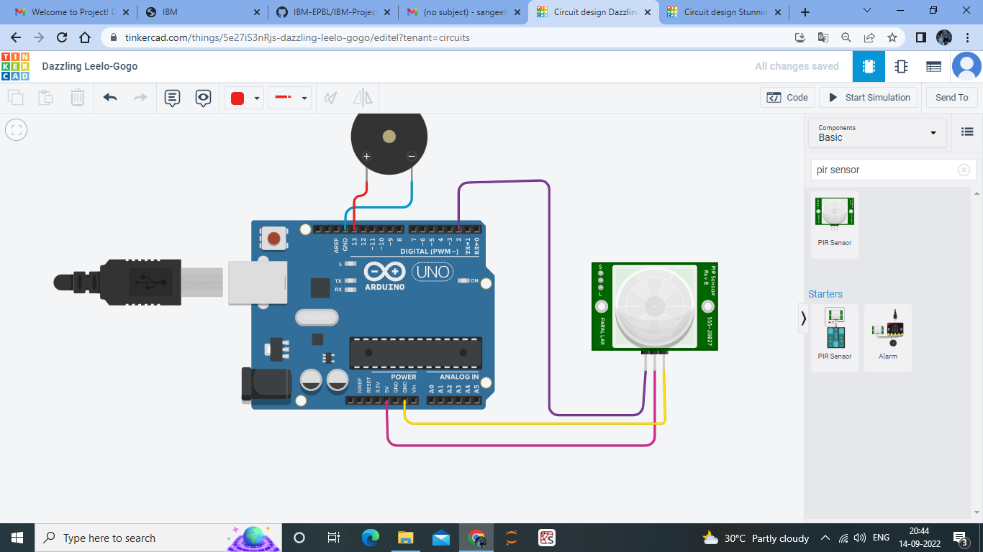

**CODING FOR CIRCUIT**

**void setup()**

**{**

**pinMode(2,INPUT);**

**pinMode(13,OUTPUT);**

**}**

**void loop()**

**{**

**if(digitalRead(2)==HIGH)**

**{**

**digitalWrite(13,HIGH);**

**}**

**else**

**{**

**digitalWrite(13,LOW);**

**}**

**delay(10); // Wait for 1000 millisecond(s)**

**}**

**CODING WITH CIRCUIT**